OUR STAFF
Pastor – Reverend Dr. Yosneis Fleitas
Pastor Emeritus - The Reverend Donald E. Davis
Organist and Choir Director- Olga Konovalova

OUR PARTNERS IN MINISTRY
The Thornwell Home for Children
The Miami Rescue Mission
The Pregnancy Resource Center
The North Campus Food Pantry for Students.
Miami Dade College

SESSION

Class of 2027 Class of 2028
Carmen Stewart Jahaira Treminio
Rafael Efrece

Moderator Clerk of Session

Rev. Dr. Yosneis Fleitas Carmen Stewart

DEACONS

Class 2026 Class 2026
Eleanor Hernandez Martha Cardona
Lisette Martinez

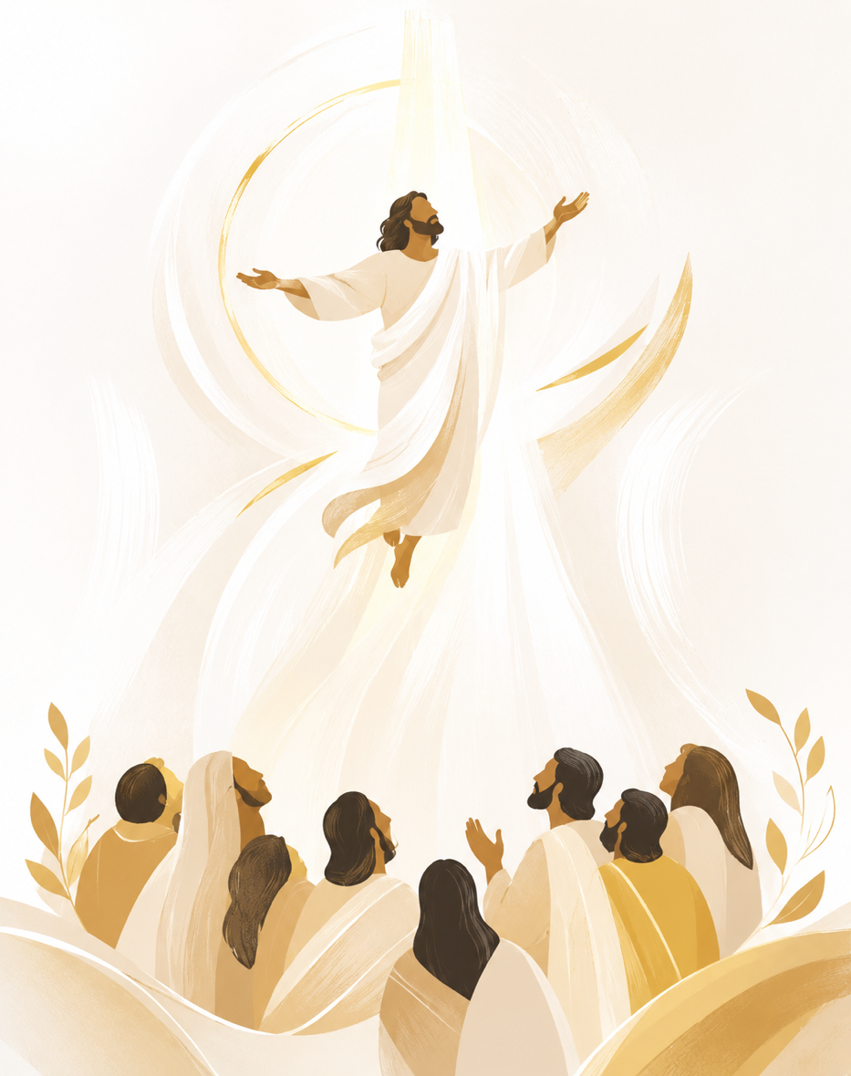

SUNRISE PRESBYTERIAN CHURCH
“Where Love Lights the Way”
“Reaching Up, Reaching In and Reaching Out to
All People.”

P.O. Box 173703, Hialeah, FL 33017
Phone: (305) 821-5841 ◦ Website: sunrisepc.org
Email: thesunrisechurch@gmail.com

Sunrise Presbyterian Church
Serving Christ and the Community for over 54 years
Christ-Centered and Biblically Founded

ASCENSION SUNDAY OF EASTER May 17, 2026

PRELUDE:
*ALL SINGING TOGETHER: “We Gather Together” (#559 first verse)
We gather together to ask the Lord's blessing;
He chastens and hastens His will to make known;
the wicked oppressing now cease from distressing.
Sing praises to His name, He forgets not His own.

CALL TO WORSHIP:
LEADER: Shout for joy, sing songs of praise,
RESPONSE: for God reigns over all the earth!
LEADER: God has gone up with a shout!
RESPONSE: Sound the trumpets and sing songs of praise!

INVOCATION

*PRAISE HYMNS
“A Mighty Fortress Is Our God”
“Celebrate Jesus Celebrate”

WELCOME AND LIFE OF THE CHURCH – Greet your neighbor with “The Peace of the Lord be with you” Response: “And Also with You.”

*HYMN “All Creatures Of Our God And King” #455

*THE APOSTLE’S CREED – page 14 of the blue hymnal

PRAYER OF CONFESSION (in unison):
Loving God, day by day we have failed to believe in your presence and in your promised forgiveness. We have not trusted in your power to give the blessings we cannot see. We have not honored our sisters and brothers as heirs of your desired peace. We have not forgiven others or ourselves. Give us the wisdom and faith to be your body on earth, that we may rejoice in the presence of your saving bounty, to the glory of your ascended Son. Amen.

PERSONAL PRAYER OF CONFESSION: in silence
ALL SINGING TOGETHER: “Come and Fill our Hearts with your Peace”
ASSURANCE OF PARDON
*DOXOLOGY

OFFERTORY INVITATION
PRESENTATION OF OFFERINGS
*ALL SINGING TOGETHER: “We Give Thee but Thine Own”

OFFERTORY PRAYER OF DEDICATION

ANTHEM “Shout With Joy To God” -Choir-

PRAYER OF ILLUMINATION

SCRIPTURE: OT. Psalm 47 / NT. Luke 24:44-53

MESSAGE: “From Promise to Praise”

*HYMN “Rejoice The Lord Is King” #155

PRAYERS OF THE PEOPLE & THE LORD’S PRAYER
All: Fill us with your power.

*HYMN “Blest Be The Tie That Binds” #438
*CHARGE AND BLESSING

*ALL SINGING TOGETHER: “Bind Us Together Lord”

POSTLUDE
Announcements
BIBLE STUDIES: Every Wednesday, at 7pm, via Zoom. We’ll be studying the parables and teachings of Jesus.
BREAD MINISTRY: The bread ministry is temporarily suspended due to the temporary closure of our neighborhood Publix.
SENDING YOUR CONTRIBUTION ONLINE: Zelle is an online tool that most banks have, it transfers money instantly without charging any fees. In this case all you need is the church's email address: thesunrisechurch@gmail.com
PER CAPITA 2026 – ALL MEMBERS: Your contribution for 2026 per capita is $38.81. Thank you for supporting our Ministries and Mission!

