OUR STAFF
Pastor – Reverend Dr. Yosneis Fleitas
Pastor Emeritus - The Reverend Donald E. Davis
Organist and Choir Director- Olga Konovalova

OUR PARTNERS IN MINISTRY
The Thornwell Home for Children
The Miami Rescue Mission
The Pregnancy Resource Center
The North Campus Food Pantry for Students.
Miami Dade College

SESSION

Class of 2027 Class of 2028
Carmen Stewart Jahaira Treminio
Rafael Efrece

Moderator Clerk of Session

Rev. Dr. Yosneis Fleitas Carmen Stewart

DEACONS

Class 2026 Class 2026
Eleanor Hernandez Martha Cardona
Lisette Martinez

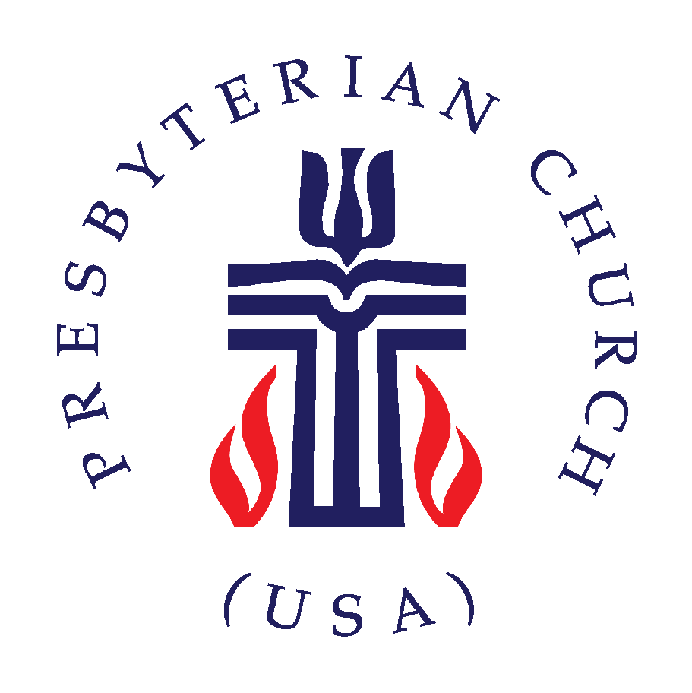

SUNRISE PRESBYTERIAN CHURCH
“Where Love Lights the Way”
“Reaching Up, Reaching In and Reaching Out to
All People.”

P.O. Box 173703, Hialeah, FL 33017
Phone: (305) 821-5841 ◦ Website: sunrisepc.org
Email: thesunrisechurch@gmail.com

Sunrise Presbyterian Church
Serving Christ and the Community for over 53 years
Christ-Centered and Biblically Founded

FIFTH SUNDAY IN LENT March 22, 2026

PRELUDE:
*ALL SINGING TOGETHER: “We Gather Together” (#559 first verse)
We gather together to ask the Lord's blessing;
He chastens and hastens His will to make known;
the wicked oppressing now cease from distressing.
Sing praises to His name, He forgets not His own.

CALL TO WORSHIP:
LEADER: O mortal, can these bones live?
RESPONSE: Only the Lord God knows.
LEADER: O people, hope in the Lord.
RESPONSE: With the Lord there is steadfast love
and great power to redeem.

INVOCATION

*PRAISE HYMNS
“I’d Rather Have Jesus”
“People Need The Lord”

WELCOME AND LIFE OF THE CHURCH – Greet your neighbor with “The Peace of the Lord be with you” Response: “And Also with You.”

*HYMN “How Firm A Foundation” #361

*THE APOSTLE’S CREED – page 14 of the blue hymnal

PRAYER OF CONFESSION (in unison):
O Lord, if you held our sin against us, who could live, who could stand? We seem to have more faith in death than hope in your promise of life. We seek peace through war and find security in weapons. We abandon the hungry, sick, and dying, and pursue wealth by making others poor. And even so, you love us; still there is forgiveness with you! Therefore, we worship you; for you alone, O Lord, can save us from death and redeem us from our sin. Amen.

PERSONAL PRAYER OF CONFESSION: in silence
ALL SINGING TOGETHER: “Come and Fill our Hearts with your Peace”
ASSURANCE OF PARDON
*DOXOLOGY

OFFERTORY INVITATION
PRESENTATION OF OFFERINGS
*ALL SINGING TOGETHER: “We Give Thee but Thine Own”

OFFERTORY PRAYER OF DEDICATION

ANTHEM “Shout With Joy To God” -Choir-

PRAYER OF ILLUMINATION

SCRIPTURE: OT. Psalm 130 / NT. John 11:1-16

MESSAGE: “Faith Between the Promise and the Miracle”

*HYMN “Breathe On Me Breath Of God” #316

PRAYERS OF THE PEOPLE & THE LORD’S PRAYER
All: Lord, remember those in need.

*HYMN “Spirit Of God Descend Upon My Heart” #326
*CHARGE AND BLESSING

*ALL SINGING TOGETHER: “Bind Us Together Lord”

POSTLUDE
Announcements
ONLINE SAFETY NOTICE: Please be aware that our church will never send emails or text messages asking for money, gift cards, credit card information, bank account details, or similar requests. If you receive such a message claiming to be from the church, please report and disregard it.
BIBLE STUDIES: Every Wednesday, at 7pm, via Zoom. We’ll be studying the parables and teachings of Jesus.
BREAD MINISTRY: The bread ministry is temporarily suspended due to the temporary closure of our neighborhood Publix.
GOOD FRIDAY DEVOTION AND PRAYER: Will be held on Good Friday, April 3rd at 6pm in the sanctuary. Please do your best to attend.

