OUR STAFF
Pastor – Reverend Dr. Yosneis Fleitas
Pastor Emeritus - The Reverend Donald E. Davis
Organist and Choir Director- Olga Konovalova

OUR PARTNERS IN MINISTRY
The Thornwell Home for Children
The Miami Rescue Mission
The Pregnancy Resource Center
The North Campus Food Pantry for Students.
Miami Dade College

SESSION

Class of 2027 Class of 2028
Donna Penny Jahaira Treminio
Carmen Stewart Rafael Efrece

Moderator Clerk of Session

Rev. Dr. Yosneis Fleitas Carmen Stewart

DEACONS

Class 2026 Class 2026
Eleanor Hernandez Martha Cardona
Lisette Martinez

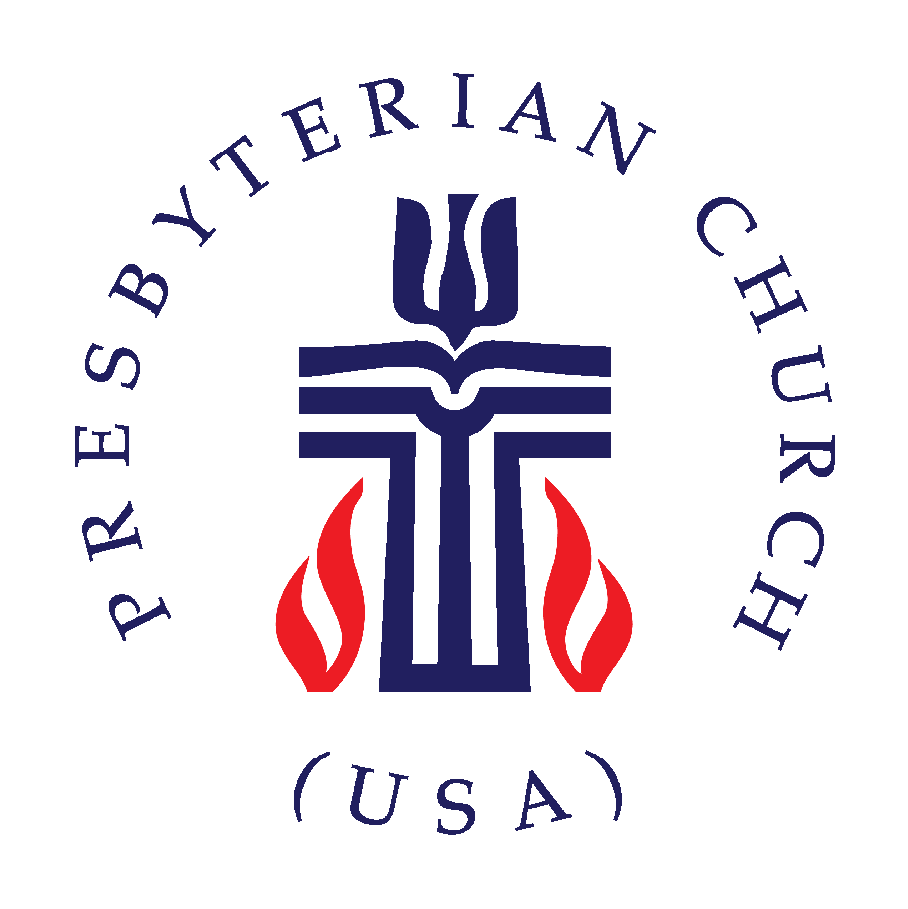

SUNRISE PRESBYTERIAN CHURCH
“Where Love Lights the Way”
“Reaching Up, Reaching In and Reaching Out to
All People.”

P.O. Box 173703, Hialeah, FL 33017
Phone: (305) 821-5841 ◦ Website: sunrisepc.org
Email: thesunrisechurch@gmail.com

Sunrise Presbyterian Church
Serving Christ and the Community for over 53 years
Christ-Centered and Biblically Founded

SECOND SUNDAY IN LENT March 3, 2026

PRELUDE:
*ALL SINGING TOGETHER: “We Gather Together” (#559 first verse)
We gather together to ask the Lord's blessing;
He chastens and hastens His will to make known;
the wicked oppressing now cease from distressing.
Sing praises to His name, He forgets not His own.

CALL TO WORSHIP:
LEADER: From where will our help come?
RESPONSE: Our help come from the Lord,
who made heaven and earth.
LEADER: Who is our keeper?
RESPONSE: The Lord is our keeper, by day and by night.
LEADER: How long will God protect us?
RESPONSE: God will keep our going out and our coming in
from this time on and forevermore.

INVOCATION

*PRAISE HYMNS
“He’s Got the Whole World in His Hands”
“I Need Thee Every Hour”

WELCOME AND LIFE OF THE CHURCH – Greet your neighbor with “The Peace of the Lord be with you” Response: “And Also with You.”

*HYMN “In the Cross of Christ I Glory” #84

*THE APOSTLE’S CREED – page 14 of the blue hymnal

PRAYER OF CONFESSION (in unison):
Gracious God, we come before you in need of forgiveness and grace. You call us to trust in you completely, but we do not. We are timid and fearful as we follow your lead. We justify our actions and words, though we know they are not what we require. We struggle to understand the new life Christ offers, preferring old habits to risky change. Forgive us, we pray. Help us to be born again into the life of Christ, trusting that you have included us by grace in the family of faith. In Christ’s name, we pray. Amen.

PERSONAL PRAYER OF CONFESSION: in silence
ALL SINGING TOGETHER: “Come and Fill our Hearts with your Peace”
ASSURANCE OF PARDON
*DOXOLOGY

OFFERTORY INVITATION
PRESENTATION OF OFFERINGS
*ALL SINGING TOGETHER: “We Give Thee but Thine Own”

OFFERTORY PRAYER OF DEDICATION

ANTHEM “Invitation To Communion” -Choir-

PRAYER OF ILLUMINATION

SCRIPTURE: Romans 4:1-5, 13-17 / John 3:1-17

MESSAGE: “Can We be Saved by Faith”

*HYMN “The Lord’s My Shepherd, I’ll Not Want” #170

PRAYERS OF THE PEOPLE & THE LORD’S PRAYER
All: Oh Lord, be our Guardian and Guide, we pray.

*HYMN “My Faith Looks Up to Thee” #383
*CHARGE AND BLESSING

*ALL SINGING TOGETHER: “Bind Us Together Lord”

POSTLUDE
Announcements
VALENTINE’S GATHERING: Thank you all for attending our Valentine gathering.
COMMUNION: Will be served on March 8th.
PER CAPITA 2026 – ALL MEMBERS: Your contribution for 2026 per capita is $38.81. Thank you for supporting our Ministries and Mission!
SENDING YOUR CONTRIBUTION ONLINE: Zelle is an online tool that most banks have, it transfers money instantly without charging any fees. In this case all you need is the church's email address: thesunrisechurch@gmail.com

