OUR STAFF
Pastor – Reverend Dr. Yosneis Fleitas
Pastor Emeritus - The Reverend Donald E. Davis
Organist and Choir Director- Olga Konovalova

OUR PARTNERS IN MINISTRY
The Thornwell Home for Children
The Miami Rescue Mission
The Pregnancy Resource Center
The North Campus Food Pantry for Students.
Miami Dade College

SESSION

Class of 2025 Class of 2027
Crescent Scott Donna Penny
Carl O’ Shields Carmen Stewart

Moderator Clerk of Session

Rev. Dr. Yosneis Fleitas Carmen Stewart

DEACONS

Class 2025 Class 2026
Andy Menyonga Eleanor Hernandez
Lisette Martinez

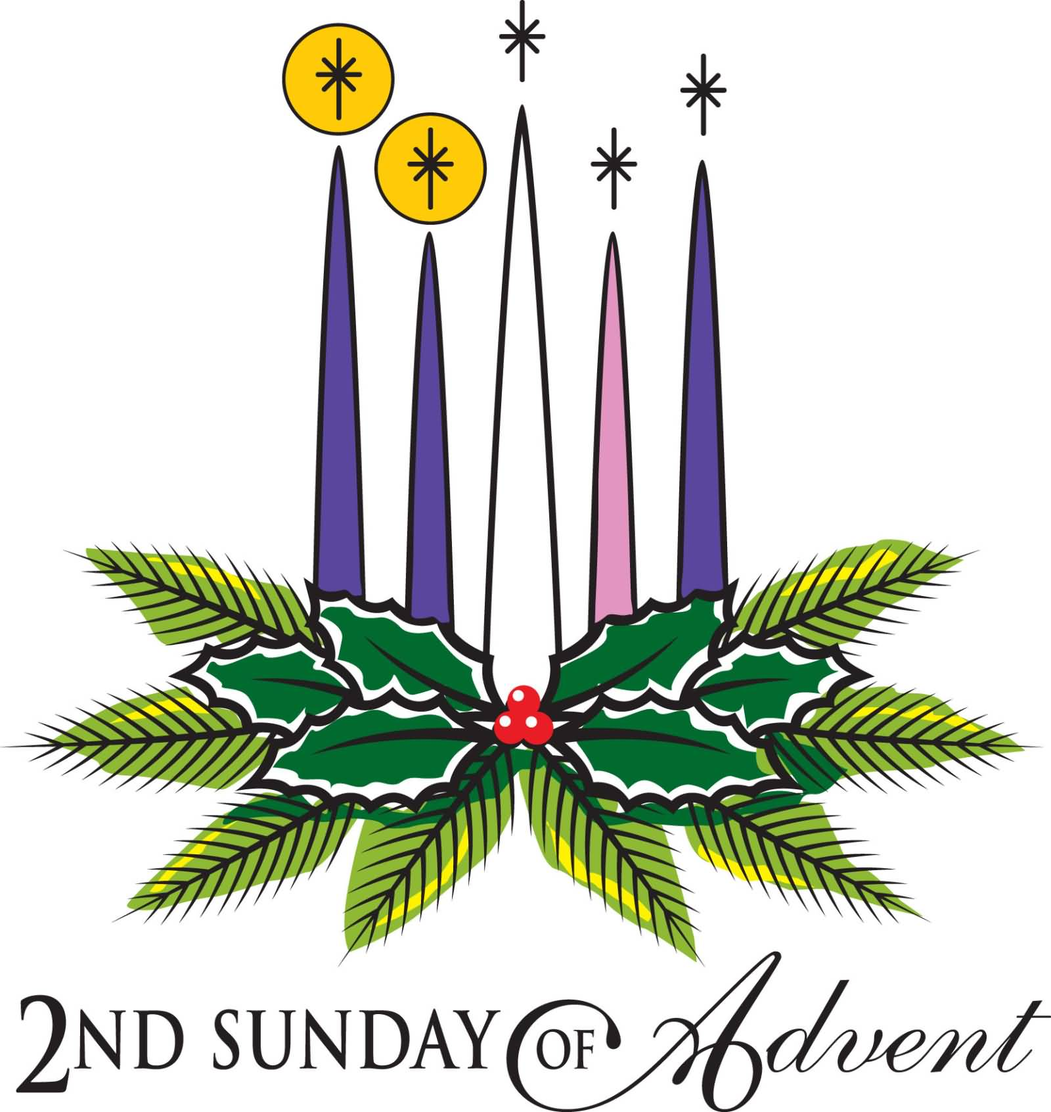

SUNRISE PRESBYTERIAN CHURCH
“Where Love Lights the Way”
“Reaching Up, Reaching In and Reaching Out to
All People.”

P.O. Box 173703, Hialeah, FL 33017
Phone: (305) 821-5841 ◦ Website: sunrisepc.org
Email: thesunrisechurch@gmail.com

Sunrise Presbyterian Church
Serving Christ and the Community for over 53 years
Christ-Centered and Biblically Founded

SECOND SUNDAY OF ADVENT December 07, 2025

PRELUDE:
*ALL SINGING TOGETHER: “We Gather Together” (#559 first verse)
We gather together to ask the Lord's blessing;
He chastens and hastens His will to make known;
the wicked oppressing now cease from distressing.
Sing praises to His name, He forgets not His own.

CALL TO WORSHIP:
LEADER: Christ the One who was, and is, and is to come,
welcomes you to this place.
as one body with one voice,
we honor and glorify the giver of wisdom,
counsel, knowledge, and joy.
RESPONSE: Amen. So be it.

LIGHTING OF THE ADVENT WREATH – The Candle of Peace

INVOCATION

*PRAISE HYMNS
“What Child Is This”

WELCOME AND LIFE OF THE CHURCH – Greet your neighbor with “The Peace of the Lord be with you” Response: “And Also with You.”

*HYMN “O Come, O Come Emmanuel” #9

*THE APOSTLE’S CREED – page 14 of the blue hymnal

PRAYER OF CONFESSION (in unison):
Gracious and welcoming God, have mercy on your people. We confess that we do not believe in your incarnation. We do not heed your Word each day in all that we say and do. We do not see our neighbors, families, and friends as beloved children whom you have made. In your mercy, forgive us, for we repent of our ways and look to your power to heal us and raise us up, so that, at the last, you will gather us to you and give us peace. Amen.

PERSONAL PRAYER OF CONFESSION: in silence
ALL SINGING TOGETHER: “Come and Fill our Hearts with your Peace”
ASSURANCE OF PARDON
*DOXOLOGY

OFFERTORY INVITATION
PRESENTATION OF OFFERINGS
*ALL SINGING TOGETHER: “We Give Thee but Thine Own”

OFFERTORY PRAYER OF DEDICATION

ANTHEM “How Majestic is Your Name” -Choir-

PRAYER OF ILLUMINATION

SCRIPTURE: OT. Isaiah 11:6-10 / NT. Matthew 3:1-12

MESSAGE: “The Fire That Heals”

*HYMN “Jesus, Thou Joy Of Loving Hearts” #510

THE SACRAMENT OF THE LORD’S SUPPER (COMMUNION)
CHOIR SINGING: “Come to the Table”

PRAYERS OF THE PEOPLE & THE LORD’S PRAYER
All: Hear us, O God; your mercy is great.

*HYMN “Lo How A Rose E’er Blooming” #48
*CHARGE AND BLESSING

*ALL SINGING TOGETHER: “Bind Us Together Lord”

POSTLUDE
Announcements
PER CAPITA 2026 – ALL MEMBERS: Your contribution for 2026 per capita is $38.81. Thank you for supporting our Ministries and Mission!
SENDING YOUR CONTRIBUTION ONLINE: Zelle is an online tool that most banks have, it transfers money instantly without charging any fees. In this case all you need is the church's email address: thesunrisechurch@gmail.com

