**OUR STAFF**

**Pastor** – Reverend Dr. Yosneis Fleitas

**Pastor Emeritus** - The Reverend Donald E. Davis

**Organist and Choir Director**- Olga Konovalova

**OUR PARTNERS IN MINISTRY**

The Thornwell Home for Children

The Miami Rescue Mission

The Pregnancy Resource Center

The North Campus Food Pantry for Students.

Miami Dade College

**SESSION**

**Class of 2025**  **Class of 2027**

Crescent Scott Donna Penny

Carl O’ Shields Carmen Stewart

**Moderator Clerk of Session**

Rev. Dr. Yosneis Fleitas Carmen Stewart

**DEACONS**

**Class 2025 Class 2026**

Andy Menyonga Eleanor Hernandez

Lisette Martinez

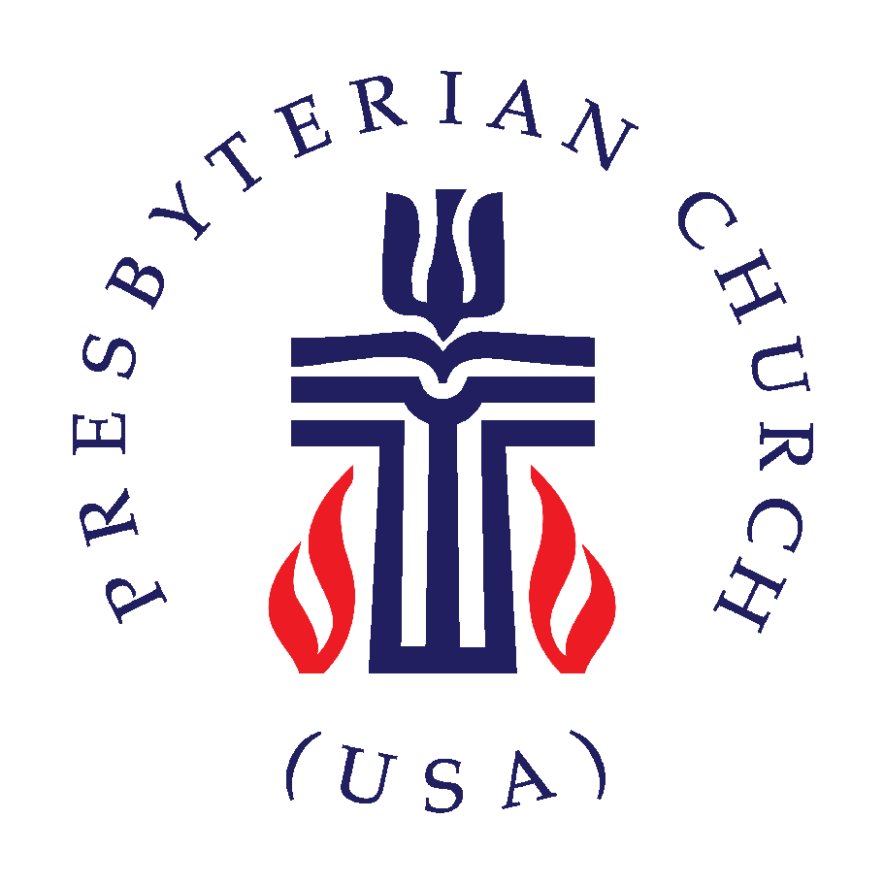

***SUNRISE PRESBYTERIAN CHURCH***

***“Where Love Lights the Way”***

***“Reaching Up, Reaching In and Reaching Out to***

***All People.”***

**P.O. Box 173703, Hialeah, FL 33017**

**Phone: (305) 821-5841 ◦ Website: sunrisepc.org**

**Email:** [**thesunrisechurch@gmail.com**](mailto:thesunrisechurch@gmail.com)

**Sunrise Presbyterian Church**

**Serving Christ and the Community for over 53 years**

**Christ-Centered and Biblically Founded**

**REFORMATION SUNDAY October 26, 2025**

**PRELUDE:**

**\*ALL SINGING TOGETHER:** “We Gather Together”(#559 first verse)

We gather together to ask the Lord's blessing;  
He chastens and hastens His will to make known;  
the wicked oppressing now cease from distressing.  
Sing praises to His name, He forgets not His own.

**CALL TO WORSHIP:**

LEADER: How lovely is your dwelling place, O Lord of host!

**RESPONSE:** **My soul longs for the courts of the Lord.**

**My being sings for joy to the living God**.

LEADER: Happy are those who live in the house of the Lord,

ever singing your praise, O God.

**INVOCATION**

\***PRAISE HYMNS**

“Celebrate Jesus Celebrate”

“Something Beautiful”

**WELCOME AND LIFE OF THE CHURCH –** Greet your neighbor with “The Peace of the Lord be with you” Response: “And Also with You.”

**\*HYMN** “The Church’s One Foundation”#442

**\*THE APOSTLE’S CREED –** page 14 of the blue hymnal

**PRAYER OF CONFESSION** (in unison):

**Merciful God, hope of your people in every age, we confess that we have sinned against you. We have wandered from your pathways, turned toward idols, lived without compassion, and disregarded the well-being of your creation. Do not turn away from us, O Lord, but renew your covenant, for only in you will our lives be healed. Guide us and lead us in your ways, for happy are those who live in your house. Amen.**

**PERSONAL PRAYER OF CONFESSION: in silence**

**ALL SINGING TOGETHER:** “Come and Fill our Hearts with your Peace”

**ASSURANCE OF PARDON**

**\*DOXOLOGY**

**OFFERTORY INVITATION**

**PRESENTATION OF OFFERINGS**

**\*ALL SINGING TOGETHER:** “We Give Thee but Thine Own”

**OFFERTORY PRAYER OF DEDICATION**

**ANTHEM**  “For The Beauty Of the Earth” -Choir-

**PRAYER OF ILLUMINATION**

**SCRIPTURE: OT.** Jeremiah 14:19-22 / **NT.** Luke 18:9-14

**MESSAGE:** “*The Power of a Humble Spirit”*

**\*HYMN** “Breathe On Me, Breath Of God”#316

**PRAYERS OF THE PEOPLE & THE LORD’S PRAYER**

***All: God of mercy, hear our prayer.***

**\*HYMN** “Great Is Thy Faithfulness” #276

**\*CHARGE AND BLESSING**

**\*ALL SINGING TOGETHER:** “Bind Us Together Lord”

**POSTLUDE**

***Announcements***

***CONGREGATIONAL MEETING:*** *November 9th at 11am in the sanctuary.*

***BIBLE STUDIES:*** *Every Wednesday (English) and Thursday (Spanish) at 7pm via Zoom. We’re studying people from the Bible.*

***OPERATION CHRISTMAS CHILD:*** *This Christmas season brighten the lives of children that have very little. National collection week this year is Nov. 17-27. For more information, please contact our Deacons.*

***SENDING YOUR CONTRIBUTION ONLINE:*** *Zelle is an online tool available through most banks, it transfers money instantly without charging any fees. To use it, all you*

*need is the church’s email address:* [*thesunrisechurch@gmail.com*](mailto:thesunrisechurch@gmail.com)*. We thank you for your generous contribution to the ministries of your church.*