**OUR STAFF**

**Pastor** – Reverend Dr. Yosneis Fleitas

**Pastor Emeritus** - The Reverend Donald E. Davis

**Organist and Choir Director**- Olga Konovalova

**OUR PARTNERS IN MINISTRY**

The Thornwell Home for Children

The Miami Rescue Mission

The Pregnancy Resource Center

The North Campus Food Pantry for Students.

Miami Dade College

**SESSION**

**Class of 2025**  **Class of 2027**

Crescent Scott Donna Penny

Carl O’ Shields Carmen Stewart

**Moderator Clerk of Session**

Rev. Dr. Yosneis Fleitas Carmen Stewart

**DEACONS**

**Class 2025 Class 2026**

Andy Menyonga Eleanor Hernandez

Lisette Martinez

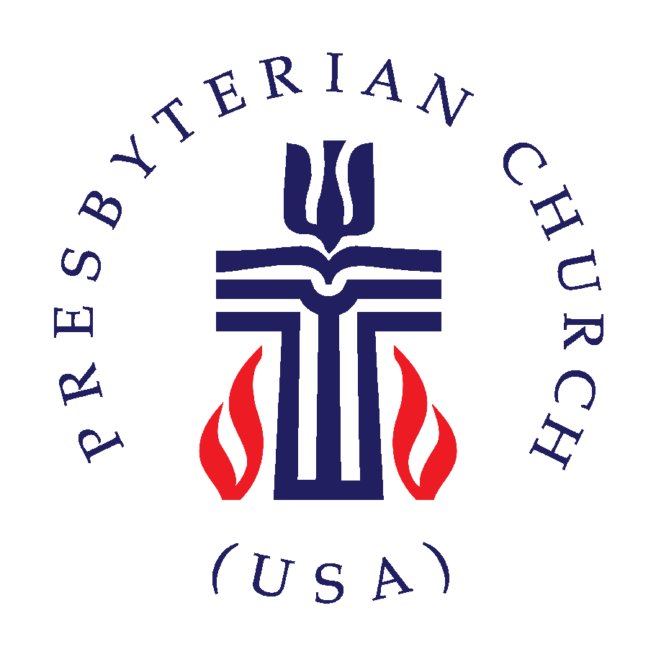

***SUNRISE PRESBYTERIAN CHURCH***

***“Where Love Lights the Way”***

***“Reaching Up, Reaching In and Reaching Out to***

***All People.”***

**P.O. Box 173703, Hialeah, FL 33017**

**Phone: (305) 821-5841 ◦ Website: sunrisepc.org**

**Email:** [**thesunrisechurch@gmail.com**](mailto:thesunrisechurch@gmail.com)

**Sunrise Presbyterian Church**

**Serving Christ and the Community for over 53 years**

**Christ-Centered and Biblically Founded**

**FOURTEENTH SUNDAY AFTER PENTECOST September 14, 2025**

**PRELUDE:**

**\*ALL SINGING TOGETHER:** “We Gather Together”(#559 first verse)

We gather together to ask the Lord's blessing;  
He chastens and hastens His will to make known;  
the wicked oppressing now cease from distressing.  
Sing praises to His name, He forgets not His own.

**CALL TO WORSHIP:**

LEADER: Rejoice with me, people of God.

**RESPONSE:** **God has gathered us in from the wilderness.**

LEADER: Rejoice with me, people of God.

**RESPONSE:** **God has swept away the darkness of the night.**

LEADER: Rejoice with me, people of God.

**RESPONSE:** **Today, there is joy in the presence of the angels.**

**INVOCATION**

\***PRAISE HYMNS**

“O Lord, Our God”

“Because He Lives”

**WELCOME AND LIFE OF THE CHURCH –** Greet your neighbor with “The Peace of the Lord be with you” Response: “And Also with You.”

**\*HYMN** “What A Friend We Have In Jesus”#403

**\*THE APOSTLE’S CREED –** page 14 of the blue hymnal

**PRAYER OF CONFESSION** (in unison):

**Oh Lord, forgive your foolish people. We are skilled in doing evil, we pretend not to know how to do good. In the folly of our hearts, we line as though there is no God. We forget all you have done for us and make false idols to be our gods. We act faithlessly, violently, and scorn your name. Create in us a clean heart, O God; put a new and right spirit within us. Amen.**

**PERSONAL PRAYER OF CONFESSION: in silence**

**ALL SINGING TOGETHER:** “Come and Fill our Hearts with your Peace”

**ASSURANCE OF PARDON**

**\*DOXOLOGY**

**OFFERTORY INVITATION**

**PRESENTATION OF OFFERINGS**

**\*ALL SINGING TOGETHER:** “We Give Thee but Thine Own”

**OFFERTORY PRAYER OF DEDICATION**

**ANTHEM**  “I’ll Fly Away” -Choir-

**PRAYER OF ILLUMINATION**

**SCRIPTURE: OT.** Psalm 14 / **NT.** Luke 15:1-10

**MESSAGE:**  “*Let’s Rejoice Together”*

**\*HYMN** “Come, Thou Fount Of Every Blessing”#356

**PRAYERS OF THE PEOPLE & THE LORD’S PRAYER**

***All: Have mercy, O God, according to your steadfast love.***

**\*HYMN** “Savior Like A Shepherd Lead Us” #387

**\*CHARGE AND BLESSING**

**\*ALL SINGING TOGETHER:** “Bind Us Together Lord”

**POSTLUDE**

***Announcements***

***WORLD COMMUNION SUNDAY:*** *We will celebrate it on the 1st Sunday of October.*

***PER CAPITA 2025 – ALL MEMBERS:*** *Your contribution for 2025 per capita is $37.89. Thank you for supporting our Ministries and Mission!*

***SENDING YOUR CONTRIBUTION ONLINE:*** *Zelle is an online tool that most banks have, it transfers money instantly without charging any fees. In this case all you need is the church's email address:* [*thesunrisechurch@gmail.com*](mailto:thesunrisechurch@gmail.com)